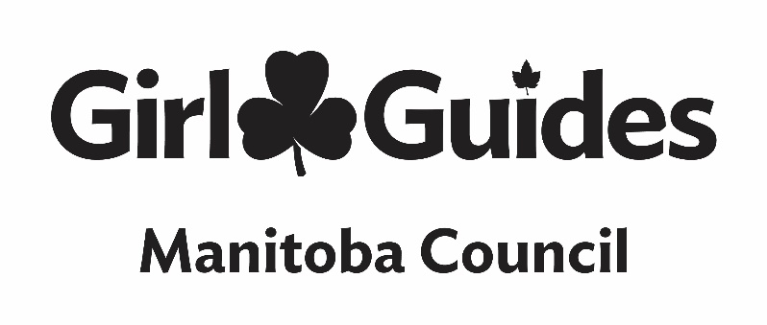

CREST ORDER FORM
Name of the crest:
Quantity needed:
If you would like the crests mailed to you, please add $3.00 to your total
Quantity x cost $ = subtotal $
Total with shipping if applicable $
Name of unit:
Contact Guider:
Address:
Email:
Payment method:
Chq #
Credit card #
Expiry date:
Send completed form with payment option to Monika at monika.theissen@girlguides.ca
Or mail to GGC MB Council 213-530 Century St Winnipeg, MB R3H 0Y4, you can also fax to 204-774-9271
PAYMENT MUST ACCOMPANY ORDER FORM.

